**RAJIV GANDHI MEMORIAL COLLEG, LENGTISIGA**

**Working days/classes /Induction day-August, 2017**

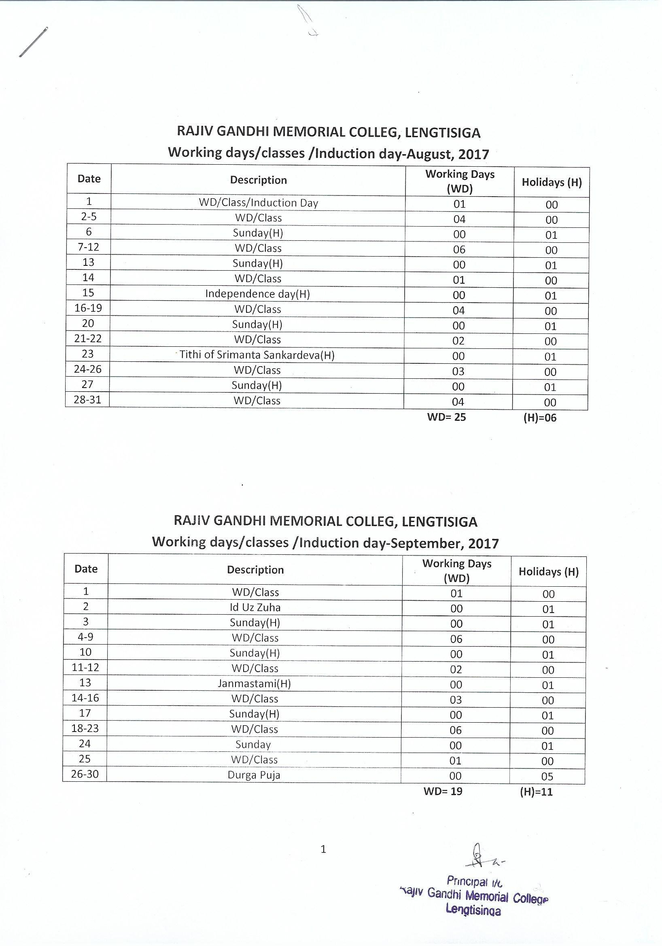

**RAJIV GANDHI MEMORIAL COLLEG, LENGTISIGA**

**Working days/classes /Induction day-October, 2017**

|  |  |  |  |
| --- | --- | --- | --- |
| **Date** | **Description** | **Working Days (WD)** | **Holidays (H)** |
| 1-5 | Durga Puj , Lakshmi Puja | 00 | 05 |
| 6-7 | WD/Class | 02 | 00 |
| 8 | Sunday(H) | 00 | 01 |
| 9-14 | WD/Class | 06 | 00 |
| 15 | Sunday(H) | 00 | 01 |
| 16-17 | WD/Class | 02 | 00 |
| 18-20 | Kati Bihu, Kali Puja & Dewali | 00 | 03 |
| 21 | WD/Class | 01 | 00 |
| 22 | Sunday(H) | 00 | 01 |
| 23-28 | WD/Class | 06 | 00 |
| 29 | Sunday | 00 | 01 |
| 30-31 | WD/Class | 02 | 00 |

**WD= 19 (H)=12**

**RAJIV GANDHI MEMORIAL COLLEG, LENGTISIGA**

**Working days/classes /Induction day-November, 2017**

|  |  |  |  |
| --- | --- | --- | --- |
| **Date** | **Description** | **Working Days (WD)** | **Holidays (H)** |
| 1-3 | WD/Class | 03 | 00 |
| 4 | Birth Day of Guru Nanak | 00 | 01 |
| 5 | Sunday(H) | 00 | 01 |
| 6-11 | WD/Class | 06 | 00 |
| 12 | Sunday(H) | 00 | 01 |
| 13-18 | WD/Class | 06 | 00 |
| 19 | Sunday (H) | 00 | 01 |
| 20-23 | WD/Class | 04 | 00 |
| 24 | Lachit Diwas | 00 | 01 |
| 25 | WD/Class | 01 | 00 |
| 26 | Sunday (H) | 00 | 01 |
| 27-30 | WD/Class | 04 | 00 |

**WD= 24 (H)= 06**

*Odd Semester Examination to be held in the month of November and December.

**RAJIV GANDHI MEMORIAL COLLEG, LENGTISIGA**

**Working days/classes /Induction day-Decmber, 2017**

|  |  |  |  |
| --- | --- | --- | --- |
| **Date** | **Description** | **Working Days (WD)** | **Holidays (H)** |
| 1 | WD/Class/Induction Day | 01 | 00 |
| 2 | Axom Diwas | 00 | 01 |
| 3 | Sunday(H) | 00 | 01 |
| 4-9 | WD/Class | 06 | 00 |
| 10 | Sunday(H) | 00 | 01 |
| 11-16 | WD/Class | 06 | 00 |
| 17 | Sunday(H) | 00 | 01 |
| 18-23 | WD/Class | 06 | 00 |
| 24 | Sunday(H) | 00 | 01 |
| 25 | Chrirstmas Day | 00 | 01 |
| 26-31 | Winter Break | 00 | 06 |

**WD = 19 (H) =12**

**RAJIV GANDHI MEMORIAL COLLEG, LENGTISIGA**

**Working days/classes /Induction day-January, 2018**

|  |  |  |  |
| --- | --- | --- | --- |
| **Date** | **Description** | **Working Days (WD)** | **Holidays (H)** |
| 1-17 | Semester Break and Magh Bihu (H) | 00 | 17 |
| 18-20 | WD/Class | 03 | 00 |
| 21 | Sunday(H) | 00 | 01 |
| 22 | Saraswati Puja (H) | 00 | 01 |
| 23-25 | WD/Class | 03 | 00 |
| 26 | Republic Day | 00 | 01 |
| 27 | WD/Class | 01 | 00 |
| 28 | Sunday(H) | 00 | 01 |
| 29-31 | WD/Class | 03 | 00 |

**WD= 10 (H)=21**

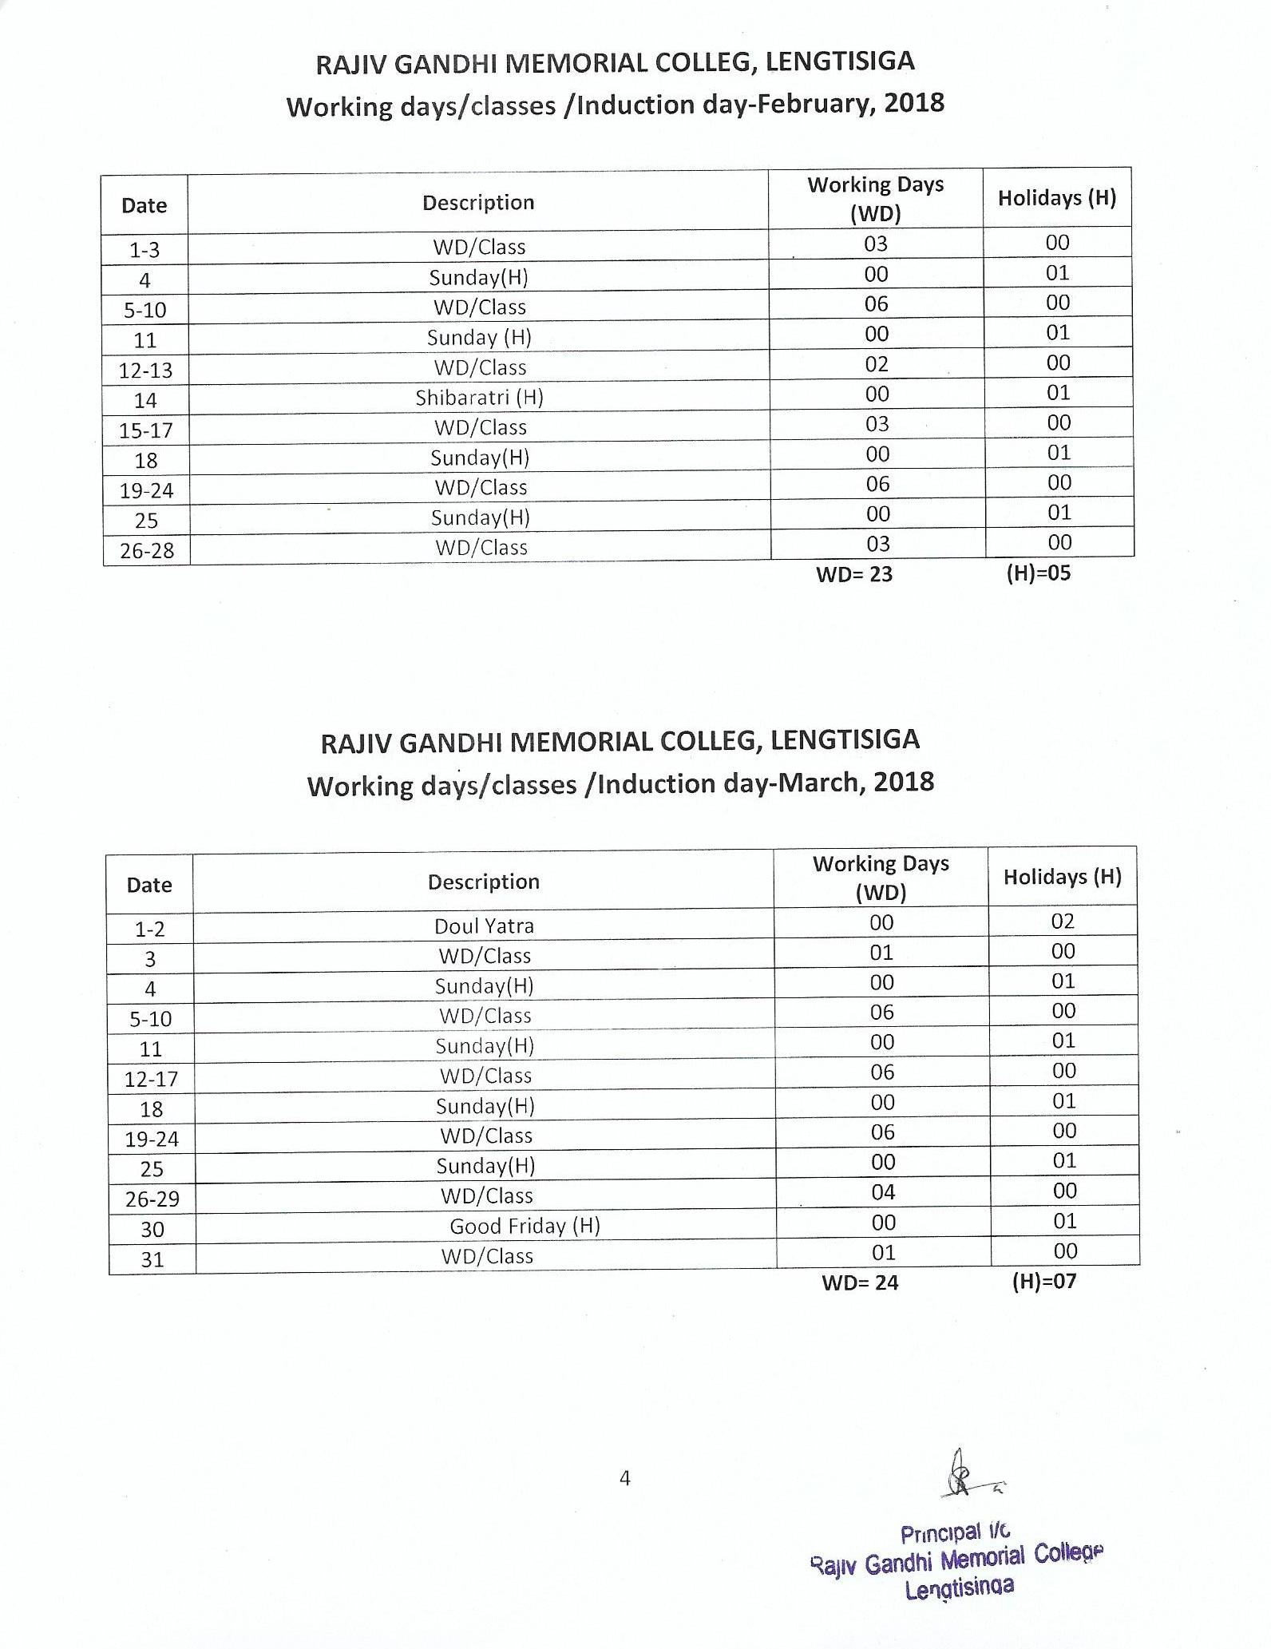

**RAJIV GANDHI MEMORIAL COLLEG, LENGTISIGA**

**Working days/classes /Induction day-April, 2018**

|  |  |  |  |
| --- | --- | --- | --- |
| **Date** | **Description** | **Working Days (WD)** | **Holidays (H)** |
| 1 | Sunday | 00 | 01 |
| 2-7 | WD/Class | 06 | 00 |
| 8 | Sunday(H) | 00 | 01 |
| 9-13 | WD/Class | 05 | 00 |
| 14-16 | Bohag Bihu (H) | 03 | 00 |
| 17-21 | WD/Class | 05 | 00 |
| 22 | Sunday(H) | 00 | 01 |
| 23-28 | WD/Class | 06 | 00 |
| 29 | Sunday(H) | 00 | 01 |
| 30 | Buddha Purnima (H) | 00 | 01 |

**WD= 25 (H)= 05**

**RAJIV GANDHI MEMORIAL COLLEG, LENGTISIGA**

**Working days/classes /Induction day-May, 2018**

|  |  |  |  |
| --- | --- | --- | --- |
| **Date** | **Description** | **Working Days (WD)** | **Holidays (H)** |
| 1 | May Day (H) | 00 | 01 |
| 2-5 | WD/Class | 04 | 00 |
| 6 | Sunday(H) | 00 | 01 |
| 7-12 | WD/Class | 06 | 00 |
| 13 | Sunday(H) | 00 | 01 |
| 14-19 | WD/Class | 06 | 00 |
| 20 | Sunday(H) | 00 | 01 |
| 21-26 | WD/Class | 06 | 00 |
| 27 | Sunday(H) | 00 | 01 |
| 28-31 | WD/Class | 04 | 00 |

**WD= 26 (H)= 05**

**RAJIV GANDHI MEMORIAL COLLEG, LENGTISIGA**

**Working days/classes /Induction day-June, 2018**

|  |  |  |  |
| --- | --- | --- | --- |
| **Date** | **Description** | **Working Days (WD)** | **Holidays (H)** |
| 1-2 | WD/Class | 02 | 00 |
| 3 | Sunday(H) | 00 | 01 |
| 4-9 | WD/Class | 06 | 00 |
| 10 | Sunday(H) | 00 | 01 |
| 11-14 | WD/Class | 04 | 00 |
| 15-16 | Id Ul Fitre | 00 | 02 |
| 17 | Sunday(H) | 00 | 01 |
| 18-23 | WD/Class | 06 | 00 |
| 24 | Sunday(H) | 00 | 01 |
| 25-30 | WD/Class | 06 | 00 |

**WD= 24 (H)= 06**

Note:

1. Summer Vacation from-01-07-2018 to 31-07-2018
2. Subject to revision as per G. U. academic calendar 2017-2018
3. Holidays mention in the calendar may be changed subject to Govt. and University notifications.
4. Dates of B. A. Semester Examinations will be notified by G.U.
5. Total Working Days= 238
6. Total Holidays= 96

** WD stands for Working Days.* (H) for Holidays