**RAJIV GANDHI MEMORIAL COLLEG, LENGTISIGA**

**Working days/classes /Induction day-August, 2018**

|  |  |  |  |
| --- | --- | --- | --- |
| **Date** | **Description** | **Working Days (WD)** | **Holidays (H)** |
| 1 | Induction Day/ WD | 01 | 00 |
| 2-4 | WD/Class | 03 | 00 |
| 5 | Sunday(H) | 00 | 01 |
| 6-11 | WD/Class | 06 | 00 |
| 12 | Sunday(H) | 00 | 01 |
| 13-14 | WD/Class | 02 | 00 |
| 15 | Independence Day(H) | 00 | 01 |
| 16 | WD/Class | 01 | 00 |
| 17 | Death of former P.M. A.B. Bajpayee (H) | 00 | 01 |
| 18 | WD/Class | 01 | 00 |
| 19 | Sunday(H) | 00 | 01 |
| 20-21 | WD/Class | 02 | 00 |
| 22-23 | Eid-uz-Zoha (H) | 00 | 02 |
| 24-25 | WD/Class | 02 | 00 |
| 26 | Sunday(H) | 00 | 01 |
| 27-30 | WD/Class | 04 | 00 |
| 31 | Tithi of Sri Sri Madhabdeva (H) | 00 | 01 |

**WD= 22 (H) = 09**

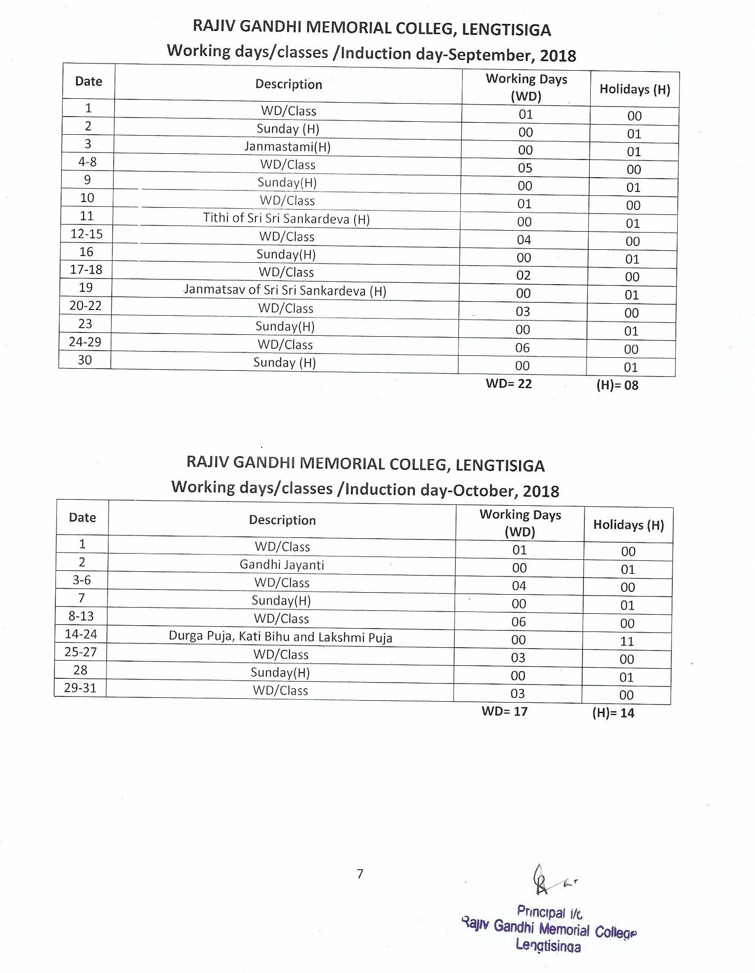

**RAJIV GANDHI MEMORIAL COLLEG, LENGTISIGA**

**Working days/classes /Induction day-November, 2018**

|  |  |  |  |
| --- | --- | --- | --- |
| **Date** | **Description** | **Working Days (WD)** | **Holidays (H)** |
| 1-3 | WD/Class | 03 | 00 |
| 4 | Sunday(H) | 00 | 01 |
| 5 | WD/Class | 01 | 00 |
| 6-7 | Kali Puja & Diwali (H) | 00 | 02 |
| 8-10 | WD/Class | 03 | 00 |
| 11 | Sunday (H) | 00 | 01 |
| 12 | WD/Class | 01 | 00 |
| 13 | Chhat Puja | 00 | 01 |
| 14-17 | WD/Class | 04 | 00 |
| 18 | Sunday (H) | 00 | 01 |
| 19-22 | WD/Class | 04 | 00 |
| 23-25 | Bithday of Guru Nanak, Lachit Diwas & Sunday (H) | 00 | 03 |
| 26-30 | WD/Class | 05 | 00 |

**WD= 21 (H)= 09**

Odd Semester Examination to be held in the months of November and December.

**RAJIV GANDHI MEMORIAL COLLEG, LENGTISIGA**

**Working days/classes /Induction day-December, 2018**

|  |  |  |  |
| --- | --- | --- | --- |
| **Date** | **Description** | **Working Days (WD)** | **Holidays (H)** |
| 1 | WD/Class | 01 | 00 |
| 2 | Sunday/Axom Diwas (H) | 00 | 01 |
| 3-8 | WD/Class | 06 | 00 |
| 9 | Sunday(H) | 00 | 01 |
| 10-15 | WD/Class | 06 | 00 |
| 16 | Sunday(H) | 00 | 01 |
| 17-22 | WD/Class | 06 | 00 |
| 23 | Sunday(H) | 00 | 01 |
| 24 | WD/Class | 01 | 00 |
| 25 | Chrirstmas Day | 00 | 01 |
| 26-31 | Semester Break (H) | 00 | 06 |

**WD= 20 (H)= 11**

**RAJIV GANDHI MEMORIAL COLLEG, LENGTISIGA**

**Working days/classes /Induction day-January, 2019**

|  |  |  |  |
| --- | --- | --- | --- |
| **Date** | **Description** | **Working Days (WD)** | **Holidays (H)** |
| 1-5 | WD/Class | 05 | 00 |
| 6 | Sunday(H) | 00 | 01 |
| 7-20 | Winter Vacation & Magh Bihu (H) | 00 | 14 |
| 21-25 | WD/Class | 05 | 00 |
| 26 | Republic Day | 00 | 01 |
| 27 | Sunday(H) | 00 | 01 |
| 28-31 | WD/Class | 04 | 00 |

**WD= 14 (H)= 17**

**RAJIV GANDHI MEMORIAL COLLEG, LENGTISIGA**

**Working days/classes /Induction day-February, 2019**

|  |  |  |  |
| --- | --- | --- | --- |
| **Date** | **Description** | **Working Days (WD)** | **Holidays (H)** |
| 1-2 | WD/Class | 02 | 00 |
| 3 | Sunday(H) | 00 | 01 |
| 4-9 | WD/Class | 06 | 00 |
| 10 | Saraswati Puja/Sunday (H) | 00 | 01 |
| 11-16 | WD/Class | 06 | 00 |
| 17 | Sunday(H) | 00 | 01 |
| 18-23 | WD/Class | 06 | 00 |
| 24 | Sunday(H) | 00 | 01 |
| 25-28 | WD/Class | 04 | 00 |

**WD= 24 (H)= 04**

**RAJIV GANDHI MEMORIAL COLLEG, LENGTISIGA**

**Working days/classes /Induction day-March, 2019**

|  |  |  |  |
| --- | --- | --- | --- |
| **Date** | **Description** | **Working Days (WD)** | **Holidays (H)** |
| 1-2 | WD/Class | 02 | 00 |
| 3 | Sunday(H) | 00 | 01 |
| 4 | Shivaratri | 00 | 01 |
| 5-9 | WD/Class | 05 | 00 |
| 10 | Sunday(H) | 00 | 01 |
| 11-16 | WD/Class | 06 | 00 |
| 17 | Sunday(H) | 00 | 01 |
| 18-20 | WD/Class | 03 | 00 |
| 21-22 | Doul Yatra (H) | 00 | 02 |
| 23 | WD/Class | 01 | 00 |
| 24 | Sunday(H) | 00 | 01 |
| 25-30 | WD/Class | 06 | 00 |
| 31 | Sunday (H) | 00 | 01 |

**WD= 23 (H)= 08**

**RAJIV GANDHI MEMORIAL COLLEG, LENGTISIGA**

**Working days/classes /Induction day-April, 2019**

|  |  |  |  |
| --- | --- | --- | --- |
| **Date** | **Description** | **Working Days (WD)** | **Holidays (H)** |
| 1-6 | WD/Class | 06 | 00 |
| 7 | Sunday(H) | 00 | 01 |
| 8-13 | WD/Class | 06 | 00 |
| 14-16 | Sunday cum Bohag Bihu (H) | 00 | 03 |
| 17-18 | WD/Class | 02 | 00 |
| 19 | Good Friday(H) | 00 | 01 |
| 20 | WD/Class | 01 | 00 |
| 21 | Sunday(H) | 00 | 01 |
| 22 | WD/Class | 01 | 00 |
| 23 | Holiday for Election | 00 | 01 |
| 24-27 | WD/Class | 04 | 00 |
| 28 | Sunday(H) | 00 | 01 |
| 29-30 | WD/Class | 02 | 00 |

**WD= 22 (H)= 08**

**RAJIV GANDHI MEMORIAL COLLEG, LENGTISIGA**

**Working days/classes /Induction day-May, 2019**

|  |  |  |  |
| --- | --- | --- | --- |
| **Date** | **Description** | **Working Days (WD)** | **Holidays (H)** |
| 1 | May Day (H) | 00 | 01 |
| 2-4 | WD/Class | 03 | 00 |
| 5 | Sunday(H) | 00 | 01 |
| 6-11 | WD/Class | 06 | 00 |
| 12 | Sunday(H) | 00 | 01 |
| 13-17 | WD/Class | 05 | 00 |
| 18 | Buddha purnima (H) | 00 | 01 |
| 19 | Sunday(H) | 00 | 01 |
| 20-25 | WD/Class | 06 | 00 |
| 26 | Sunday(H) | 00 | 01 |
| 27-31 | WD/Class | 05 | 00 |

**WD= 25 (H)= 06**

Even Semester Final Examination to be held in the months of May and June.

**RAJIV GANDHI MEMORIAL COLLEG, LENGTISIGA**

**Working days/classes /Induction day-June, 2019**

|  |  |  |  |
| --- | --- | --- | --- |
| **Date** | **Description** | **Working Days (WD)** | **Holidays (H)** |
| 1 | WD/Class | 01 | 00 |
| 2 | Sunday(H) | 00 | 01 |
| 3-4 | WD/Class | 02 | 00 |
| 5-6 | Idul-Fitre | 00 | 02 |
| 7-8 | WD/Class | 02 | 00 |
| 9 | Sunday(H) | 00 | 01 |
| 10-15 | WD/Class | 06 | 00 |
| 16 | Sunday(H) | 00 | 01 |
| 17-22 | WD/Class | 06 | 00 |
| 23 | Sunday(H) | 00 | 01 |
| 24-29 | WD/Class | 06 | 00 |
| 30 | Sunday(H) | 00 | 01 |

**WD= 23 (H)= 07**

Note:

1. Summer Vacation from-01-07-2019 to 31-07-2019
2. Subject to revision as per G. U. academic calendar 2018-2019
3. Holidays mention in the calendar may be changed subject to Govt. and University notifications.
4. Dates of B. A. Semester Examinations will be notified by G.U.
5. Total Working Days= 233
6. Total Holidays= 101

**\*\* WD stands for Working Days.* (H) for Holidays.**