**RAJIV GANDHI MEMORIAL COLLEG, LENGTISIGA**

**Working days/classes /Induction day-August, 2019**

|  |  |  |  |
| --- | --- | --- | --- |
| **Date** | **Description** | **Working Days (WD)** | **Holidays (H)** |
| 1 | Induction Day/ WD | 01 | 00 |
| 2-3 | WD/Class | 02 | 00 |
| 4 | Sunday(H) | 00 | 01 |
| 5-10 | WD/Class | 06 | 00 |
| 11 | Sunday(H) | 00 | 01 |
| 12-13 | Id-uz-zuha | 00 | 02 |
| 14 | WD/Class | 01 | 00 |
| 15 | Independence Day (H) | 00 | 01 |
| 16-17 | WD/Class | 02 | 00 |
| 18 | Sunday(H) | 00 | 01 |
| 19 | WD/Class | 01 | 00 |
| 20 | Tithi of Sri Sri Madava Deva (H) | 00 | 01 |
| 21-22 | WD/Class | 02 | 00 |
| 23 | Janmastomy(H) | 00 | 01 |
| 24 | WD/Class | 01 | 00 |
| 25 | Sunday(H) | 00 | 01 |
| 26-31 | WD/Class | 06 | 00 |

**WD= 22 (H)= 09**

**RAJIV GANDHI MEMORIAL COLLEG, LENGTISIGA**

**Working days/classes /Induction day-September, 2019**

|  |  |  |  |
| --- | --- | --- | --- |
| **Date** | **Description** | **Working Days (WD)** | **Holidays (H)** |
| 1 | Sunday (H) | 00 | 01 |
| 2-7 | WD/Class | 06 | 00 |
| 8 | Sunday (H) | 00 | 01 |
| 9-14 | WD/Class | 06 | 00 |
| 15 | Sunday(H) | 00 | 01 |
| 16-21 | WD/Class | 06 | 00 |
| 22 | Sunday(H) | 00 | 01 |
| 23-28 | WD/Class | 06 | 00 |
| 29 | Sunday(H) | 00 | 01 |
| 30 | WD/Class | 01 | 00 |

**WD= 25 (H)= 05**

**RAJIV GANDHI MEMORIAL COLLEG, LENGTISIGA**

**Working days/classes /Induction day-October, 2019**

|  |  |  |  |
| --- | --- | --- | --- |
| **Date** | **Description** | **Working Days (WD)** | **Holidays (H)** |
| 1 | WD/Class | 01 | 00 |
| 2 | Gandhi Jayanti | 00 | 01 |
| 3-4 | WD/Class | 02 | 00 |
| 5-13 | Durga puja, Laxmi Puja, Birth Anniversary of Sankardeva | 00 | 09 |
| 14-17 | WD/Class | 04 | 00 |
| 18 | Kati Bihu | 00 | 01 |
| 19 | WD/Class | 01 | 00 |
| 20 | Sunday(H) | 00 | 01 |
| 21-26 | WD/Class | 06 | 00 |
| 27-28 | Kali Puja/ Diwali | 00 | 02 |
| 29-31 | WD/Class | 03 | 00 |

**WD= 17 (H)= 14**

**RAJIV GANDHI MEMORIAL COLLEG, LENGTISIGA**

**Working days/classes /Induction day-November, 2019**

|  |  |  |  |
| --- | --- | --- | --- |
| **Date** | **Description** | **Working Days (WD)** | **Holidays (H)** |
| 1-2 | WD/Class | 02 | 00 |
| 3 | Sunday(H) | 00 | 01 |
| 4-9 | WD/Class | 06 | 00 |
| 10 | Sunday(H) | 00 | 01 |
| 11 | WD/Class | 01 | 00 |
| 12 | Bithday of Guru Nanak | 00 | 01 |
| 13-16 | WD/Class | 04 | 00 |
| 17 | Sunday (H) | 00 | 01 |
| 18-23 | WD/Class | 06 | 00 |
| 24 | Sunday (H) | 00 | 01 |
| 25-30 | WD/Class | 06 | 00 |

**WD= 25 (H)= 05**

**\***Even Semester Examination to be held in the months of November and December.

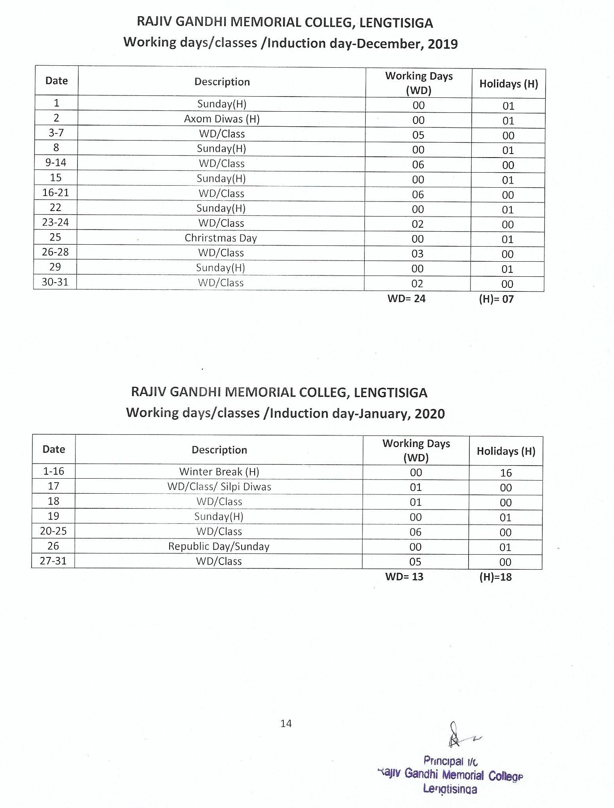

**RAJIV GANDHI MEMORIAL COLLEG, LENGTISIGA**

**Working days/classes /Induction day-February, 2020**

|  |  |  |  |
| --- | --- | --- | --- |
| **Date** | **Description** | **Working Days (WD)** | **Holidays (H)** |
| 1 | WD/Class | 01 | 00 |
| 2 | Sunday(H) | 00 | 01 |
| 3-8 | WD/Class | 06 | 00 |
| 9 | Sunday(H) | 00 | 01 |
| 10-15 | WD/Class | 06 | 00 |
| 16 | Sunday(H) | 00 | 01 |
| 17-20 | WD/Class | 04 | 00 |
| 21 | Siva Ratri | 00 | 01 |
| 22 | WD/Class | 01 | 00 |
| 23 | Sunday(H) | 00 | 01 |
| 24-29 | WD/Class | 06 | 00 |

**WD= 24 (H)= 05**

**RAJIV GANDHI MEMORIAL COLLEG, LENGTISIGA**

**Working days/classes /Induction day-March, 2020**

|  |  |  |  |
| --- | --- | --- | --- |
| **Date** | **Description** | **Working Days (WD)** | **Holidays (H)** |
| 1 | Sunday(H) | 00 | 01 |
| 2-7 | WD/Class | 06 | 00 |
| 8 | Sunday(H) | 00 | 01 |
| 9-10 | Doul Yatra | 00 | 02 |
| 11-14 | WD/Class | 04 | 00 |
| 15 | Sunday(H) | 00 | 01 |
| 16-21 | WD/Class | 06 | 00 |
| 22 | Sunday | 00 | 01 |
| 23-28 | WD/Class | 06 | 00 |
| 29 | Sunday | 00 | 01 |
| 30-31 | WD/Class | 02 | 00 |

**WD= 24 (H)= 07**

**Note: from 25-03-2020, lockdown started on account of Covid-19 pandemic.**

**RAJIV GANDHI MEMORIAL COLLEG, LENGTISIGA**

**Working days/classes /Induction day-April, 2020**

|  |  |  |  |
| --- | --- | --- | --- |
| **Date** | **Description** | **Working Days (WD)** | **Holidays (H)** |
| 1-4 | WD/Class | 04 | 00 |
| 5 | Sunday(H) | 00 | 01 |
| 6-9 | WD/Class | 04 | 00 |
| 10 | Good Friday(H) | 00 | 01 |
| 11 | WD/Class | 01 | 00 |
| 12 | Sunday(H) | 00 | 01 |
| 13-15 | Bohag Bihu | 00 | 03 |
| 16-18 | WD/Class | 03 | 00 |
| 19 | Sunday(H) | 00 | 01 |
| 20-25 | WD/Class | 06 | 00 |
| 26 | Sunday(H) | 00 | 01 |
| 27-30 | WD/Class | 04 | 00 |

**WD= 22 (H)= 08**

**RAJIV GANDHI MEMORIAL COLLEG, LENGTISIGA**

**Working days/classes /Induction day-May, 2020**

|  |  |  |  |
| --- | --- | --- | --- |
| **Date** | **Description** | **Working Days (WD)** | **Holidays (H)** |
| 1 | May Day (H) | 00 | 01 |
| 2 | WD/Class | 01 | 00 |
| 3 | Sunday(H) | 00 | 01 |
| 4-6 | WD/Class | 03 | 00 |
| 7 | Buddha Purnima(H) | 00 | 01 |
| 8-9 | WD/Class | 02 | 00 |
| 10 | Sunday(H) | 00 | 01 |
| 11-16 | WD/Class | 06 | 00 |
| 17 | Sunday(H) | 00 | 01 |
| 18-23 | WD/Class | 06 | 00 |
| 24 | Sunday(H) | 00 | 01 |
| 25-26 | Id-Ul-Fitre | 00 | 02 |
| 27-30 | WD/Class | 04 | 00 |
| 31 | Sunday (H)00 | 00 | 01 |

**WD= 22 (H)= 09**

**RAJIV GANDHI MEMORIAL COLLEG, LENGTISIGA**

**Working days/classes /Induction day-June, 2020**

|  |  |  |  |
| --- | --- | --- | --- |
| **Date** | **Description** | **Working Days (WD)** | **Holidays (H)** |
| 1-6 | WD/Class | 06 | 00 |
| 7 | Sunday(H) | 00 | 01 |
| 8-13 | WD/Class | 06 | 00 |
| 14 | Sunday(H) | 00 | 01 |
| 15-20 | WD/Class | 06 | 00 |
| 21 | Sunday(H) | 00 | 01 |
| 22-27 | WD/Class | 06 | 00 |
| 28 | Sunday(H) | 00 | 01 |
| 29-30 | WD/Class | 02 | 00 |

**WD= 26 (H)= 04**

Note:

(i) Summer Vacation from-01-07-2020 to 31-07-2020

**(ii)** Subject to revision as per G. U. academic calendar 2019-2020

(iii) Holidays mention in the calendar may be changed subject to Govt. and University notifications.

(iv) Dates of B. A. Semester Examinations will be notified by G.U.

(v) Total Working Days= 244

(vi) Total Holidays= 91

** WD stands for Working Days.* (H) for Holidays